UNIT-3﻿
Virtualization and Containers﻿
3.1 Virtualization and Containers :﻿
Virtualization:﻿
Virtualization is a technology that creates virtual versions of computer resources such as hardware platforms, operating systems, storage devices, and network resources. It’s like creating a software-based replica of a physical machine, allowing you to run multiple isolated environments on the same hardware or across a distributed system.﻿
Functions :﻿
1.Imagine you have a powerful computer but you only use a small portion of its resources. ﻿
2.Virtualization allows you to split that computer into several virtual machines (VMs), each acting like a separate 3.computer with its operating system and applications. ﻿
4.Each virtual machine is isolated from the others, meaning issues in one virtual machine won’t affect others. ﻿
Containerization :﻿
Containerization is a lightweight form of virtualization that allows you to run applications and their dependencies in isolated containers. Each container shares the same operating system kernel but is isolated from other containers, providing a portable and consistent runtime environment for applications.﻿
Functions:﻿
1.Containers provide process isolation, ensuring that applications running in one container do not affect applications running in other containers.﻿
2.Containers encapsulate all dependencies and configuration required to run an application, making them portable across different environments.﻿
3.Containers are lightweight compared to traditional virtual machines (VMs) because they share the host operating system kernel.﻿
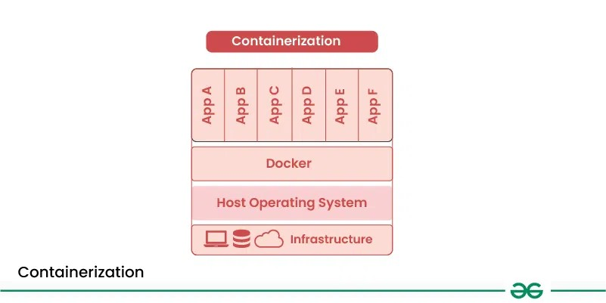
﻿
Conclusion﻿
Virtualization and containerization are two distinct technologies that offer unique advantages and use cases. Virtualization provides strong isolation and flexibility, making it suitable for running legacy applications and environments with specific operating system requirements. On the other hand, containerization offers lightweight and portable runtime environments, making it ideal for modern, cloud-native applications and microservices architectures.﻿
3.2 ﻿
Characteristics of virtualized environment﻿
1. Increased Security : ﻿
The ability to control the execution of a guest program in a completely transparent manner opens new possibilities for delivering a secure, controlled execution environment. All the operations of the guest programs are generally performed against the virtual machine, which then translates and applies them to the host programs. ﻿
2. Managed Execution - ﻿
In particular, sharing, aggregation, emulation, and isolation are the most relevant features. ﻿
3.Sharing - ﻿
Virtualization allows the creation of a separate computing environment within the same host. This basic feature is used to reduce the number of active servers and limit power consumption. ﻿
4. Isolation - ﻿
Virtualization allows providing guests—whether they are operating systems, applications, or other entities—with a completely separate environment, in which they are executed. The guest program performs its activity by interacting with an abstraction layer, which provides access to the underlying resources. The virtual machine can filter the activity of the guest and prevent harmful operations against the host. ﻿
5.Resource sharing:﻿
Virtualization allows multiple virtual machines to share the resources of a single physical machine, such as CPU, memory, storage, and network bandwidth. This improves hardware utilization and reduces the need for additional physical servers.﻿
6.Flexibility: ﻿
Virtualization allows IT administrators to quickly and easily create, modify, or delete virtual machines as needed, without the need to purchase and configure additional physical hardware.﻿
7.Scalability:﻿
Virtualization allows organizations to scale their computing resources up or down as needed, depending on changing business requirements.﻿
8.Cost Savings:﻿
Virtualization can help organizations save money by reducing the need for additional physical hardware, lowering electricity bills, and streamlining IT operations. This can result in significant cost savings over time.﻿
3.3﻿
Texamony of virtualization techniques :﻿﻿
1. Application Virtualization: Application virtualization enables remote access by which users can directly interact with deployed applications without installing them on their local machine. Your personal data and the applications settings are stored on the server, but you can still run it locally via the internet. It’s useful if you need to work with multiple versions of the same software. Common examples include hosted or packaged apps.﻿﻿
Example: Microsoft Azure lets people use their applications without putting them on their own computers. Once this application is setup in the cloud then employees can use it from any device, like a laptop or tablet. It feels like the application is on their computer, but it’s really running on Azure’s servers. This makes things easier, faster, and safer for the company.﻿﻿
2. Network Virtualization: This allows multiple virtual networks to run on the same physical network, each operating independently. You can quickly set up virtual switches, routers, firewalls, and VPNs, making network management more flexible and efficient.﻿﻿
Example: Google Cloud is an example of Network Virtualization. Companies create their own networks using software instead of physical devices with the help of Google Cloud. They can set up things like IP addresses, firewalls, and private connections all in the cloud. This makes it easy to manage, change, and grow their network without buying any hardware. It saves time, money, and gives more flexibility﻿
3. Desktop Virtualization: Desktop virtualization is a process in which you can create different virtual desktops that users can use from any device like laptop, tablet. It’s great for users who need flexibility, as it simplifies software updates and provides portability.﻿﻿
Example: GeeksforGeeks is a Edtech company which uses services like Amazon WorkSpaces or Google Cloud (GCP) Virtual Desktops to give its team members access to the same coding setup with all the tools they required for the easy access of this team work. Now their team members can easily log in from any device like a laptop, tablet, or even a phone and use a virtual desktop that will run perfectly in the cloud. This makes it easy for GeeksforGeeks company to manage, update, and keep everything secure without requirement of physical computers for everyone.﻿﻿
4. Storage Virtualization: This combines storage from different servers into a single system, making it easier to manage. It ensures smooth performance and efficient operations even when the underlying hardware changes or fails.﻿﻿
Example: Amazon S3 is an example of storage virtualization because in S3 we can easily store any amount of data from anywhere. Suppose a MNC have lots of files and data of company to store. By Amazon S3 company can store all their files and data in one place and access these from anywhere without any kind of issue in secure way.﻿﻿
5. Server Virtualization: This splits a physical server into multiple virtual servers, each functioning independently. It helps improve performance, cut costs and makes tasks like server migration and energy management easier.﻿﻿
6. Data Virtualization: This brings data from different sources together in one place without needing to know where or how it’s stored. It creates a unified view of the data, which can be accessed remotely via cloud services.﻿﻿
Example: Companies like Oracle and IBM offer solutions for this.﻿﻿
3.4 Virulazation and cloud computing :﻿
What is Cloud Computing?﻿
Cloud computing is a client-server computing architecture. In cloud computing, resources are used in centralized pattern and cloud computing is a high accessible service. Cloud computing is a payment and useful business tool, users pay for usage. ﻿﻿
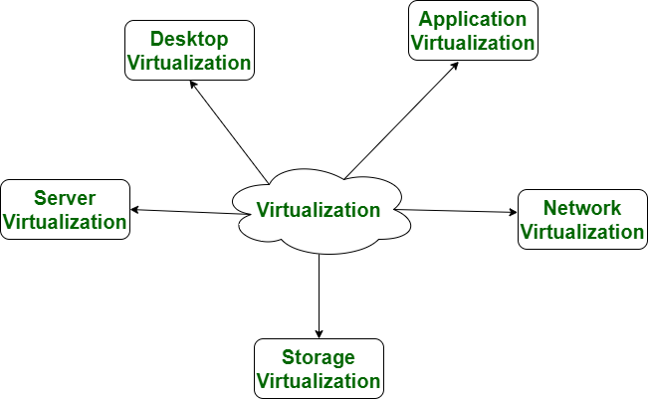

What is Cloud Computing?
Cloud computing is a client-server computing architecture. In cloud computing, resources are used in centralized pattern and cloud computing is a high accessible service. Cloud computing is a payment and useful business tool, users pay for usage. ﻿
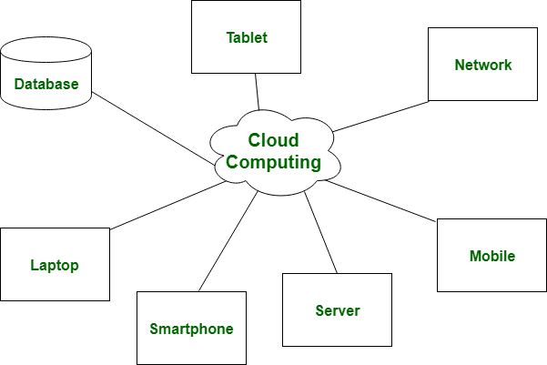
3.5 Prons and cons of virtualization :﻿
﻿﻿
Pros of Virtualization﻿
1.Utilization of Hardware Efficiently: With the help of Virtualization Hardware is Efficiently used by user as well as Cloud Service Provider. In this the need of Physical Hardware System for the User is decreases and this results in less costly.In Service Provider point of View, they will utilize the Hardware using Hardware Virtualization which decrease the Hardware requirement from Vendor side.﻿
2.High Availability: One of the main benefit of Virtualization is that it provides advance features which allow virtual instances to be available all the times.﻿
Disaster Recovery is efficient and easy: With the help of virtualization Data Recovery, Backup, Duplication becomes very easy. In traditional method , if somehow due to some disaster if Server system Damaged then the surety of Data Recovery is very less. But with the tools of Virtualization real time data backup recovery and mirroring become easy task and provide surety of zero percent data loss.﻿
3 Virtualization saves Energy: Virtualization will help to save Energy because while moving from physical Servers to Virtual Server's, the number of Server's decreases due to this monthly power and cooling cost decreases which will Save Money as well.﻿
4.Quick and Easy Set up: In traditional methods Setting up physical system and servers are very time-consuming. Firstly Purchase them in bulk after that wait for shipment. When Shipment is done then wait for Setting up and after that again spend time in installing required software etc. Which will consume very time. But with the help of virtualization the entire process is done in very less time which results in productive setup.﻿
5 Cloud Migration becomes easy: Most of the companies those who already have spent a lot in the server have a doubt of Shifting to Cloud. But it is more cost-effective to shift to cloud services because all the data that is present in their server's can be easily migrated into the cloud server and save something from maintenance charge, power consumption, cooling cost, cost to Server Maintenance Engineer etc.﻿
Resource Optimization: Virtualization allows efficient utilization of physical hardware by running multiple virtual machines (VMs) on a single physical server. This consolidation leads to cost savings in terms of hardware, power, cooling, and space﻿
-Cons of Virtualization﻿
1.High Initial Investment: While virtualization reduces costs in the long run, the initial setup costs for storage and servers can be higher than a traditional setup.﻿
2.Complexity: Managing virtualized environments can be complex, especially as the number of VMs increases.﻿
3 Security Risks: Virtualization introduces additional layers, which may pose security risks if not properly configured and monitored.﻿
4 Learning New Infrastructure: As Organization shifted from Servers to Cloud. They required skilled staff who can work with cloud easily. Either they hire new IT staff with relevant skill or provide training on that skill which increase the cost of company.﻿
5 .Data can be at Risk: Working on virtual instances on shared resources means that our data is hosted on third party resource which put's our data in vulnerable condition. Any hacker can attack on our data or try to perform unauthorized access. Without Security solution our data is in threaten situation.﻿
3 .6 Technology examples (XEN, VMware), :﻿
Xen is an open source hypervisor based on paravirtualization. It is the most popular application of paravirtualization. Xen has been extended to compatible with full virtualization using hardware-assisted virtualization. It enables high performance to execute guest operating system. This is probably done by removing the performance loss while executing the instructions requiring significant handling and by modifying portion of the guest operating system executed by Xen, with reference to the execution of such instructions. Hence this especially support x86, which is the most used architecture on commodity machines and servers. ﻿
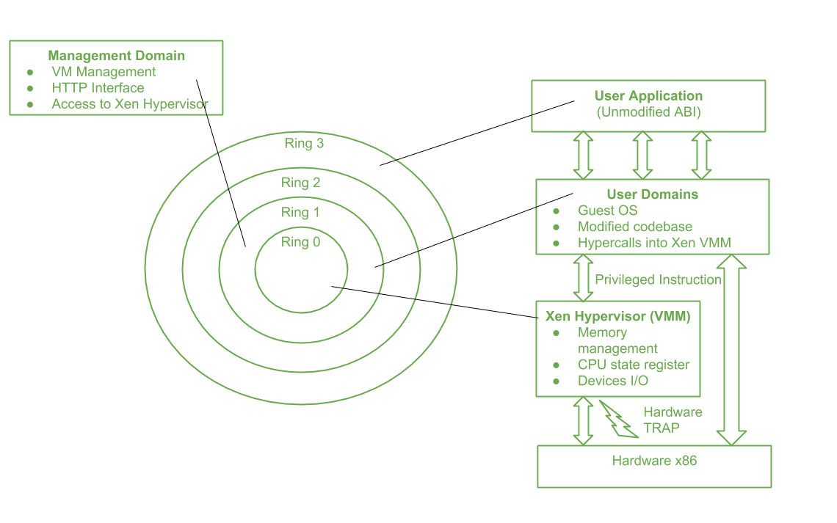
Above figure describes the Xen Architecture and its mapping onto a classic x86 privilege model. A Xen based system is handled by Xen hypervisor, which is executed in the most privileged mode and maintains the access of guest operating system to the basic hardware. Guest operating system are run between domains, which represents virtual machine instances. ﻿
Various x86 implementation support four distinct security levels, termed as rings, i.e﻿
Ring 0, Ring 1, Ring 2, Ring 3﻿
-VM WARE :﻿
VMware is widely used as it tends to virtualize x86 architectures, which execute unmodified on-top of their hypervisors. With the introduction of hardware-assisted virtualization, full virtualization is possible to achieve with the support of hardware. But earlier, x86 guest operating systems unmodified in a virtualized environment could be executed only with the use of dynamic binary translation. ﻿
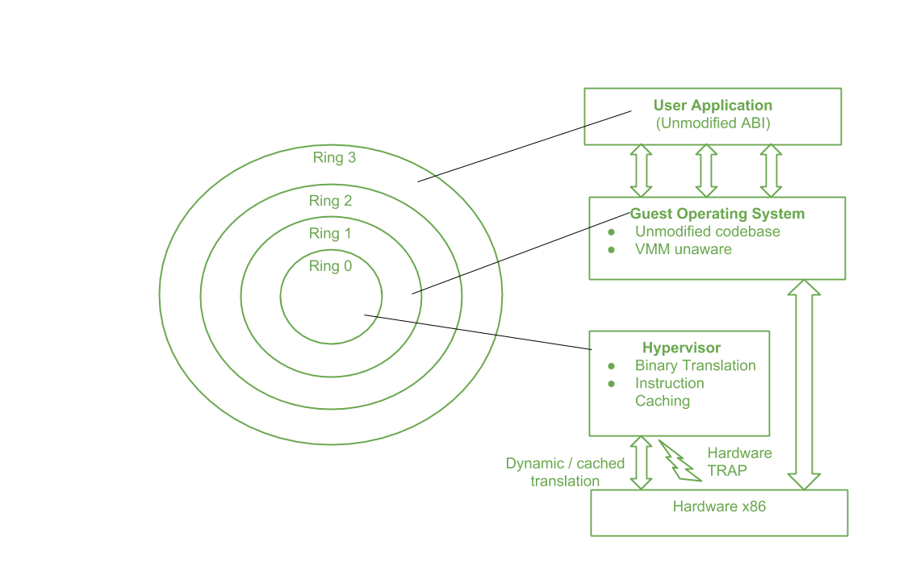
Figure - Full Virtualization Reference Model The major benefit of this approach is that guests can run unmodified in a virtualized environment, which is an important feature for operating system whose source code does not existed. Binary translation is portable for full virtualization. As well as translation of instructions at runtime presents an additional overhead that is not existed in other methods like paravirtualization or hardware-assisted virtualization. Contradict, binary translation is only implemented to a subset of the instruction set, while the others are managed through direct execution on the primary hardware. This depletes somehow the impact on performance of binary translation. ﻿
-Advantages of Binary Translation – ﻿
1.This kind of virtualization delivers the best isolation and security for Virtual Machine.﻿
2.Truly isolated numerous guest OS can execute concurrently on the same hardware.﻿
3.It is only implementation that needs no hardware assist or operating system assist to virtualize sensitive instruction as well as privileged instruction﻿
-Disadvantages of Binary Translation – ﻿
1.It is time consuming at run-time.﻿
2.It acquires a large performance overhead.﻿
3.It employs a code cache to stock the translated most used instructions to enhance the performance, but it increases memory utilization along with the hardware cost.﻿
4.The performance of full virtualization on the x86 architecture is 80 to 95 percent that of the host machine.﻿
3.7 Building blocks of containers :﻿
Linux kernel features that software like Docker is using to make the containers work and provide those isolated environments that we all use. then towards the end of this section, we'll also take a look at the docker system architecture.﻿
-The building blocks of containers﻿
There are three technologies that make up the core of a container.﻿
1.Namespaces﻿
2.Control groups﻿
3.Union file systems﻿
1.Namespaces. -﻿
The technical definition of Namespaces - "A namespace wraps a global system resource in an abstraction that makes it appear to the processes within the namespace that they have their own isolated instance of the global resource. Changes to the global resource are visible to other processes that are members of the namespace but are invisible to other processes."﻿
Now simpler terms Namespaces are a way, or a mechanism used to wrap any global system resource such that the processes that are running within the namespace thinks that they have their own isolated instance of that resource, and they cannot see things happening outside of their own instance. Its just like the processes do not know what's happening outside the namespace, they are only worried about what's confined inside that particular namespace.﻿
For example, there is a namespace called PID, the full form is Process ID namespace. The PID namespace is isolated within a container such that within the PID namespace, the process you will run will appear to be process ID number one even though there may be tons of other processes running on the host. From inside the container, we don't know anything about those host processes, and we essentially think that we are the only thing running in this system.﻿
C groups or Control groups﻿
The technical definition of Control groups - "a Linux kernel feature which allow processes to be organized into hierarchical groups whose usage of various types of resources can then be limited and monitored."﻿
C groups are a Linux kernel feature that allows us to organize our processes into groups which we can then limit and monitor access to certain resources. The reason why C groups are important is that it allows us to avoid something called a "Noisy Neighbor" problem where one application is very resource hungry, and it starves the other applications of resources. By using c groups, we can isolate them from a performance perspective.﻿
Union Mount Filesystems (OverlayFS)﻿
The Technical definition of Union Mount Filesystems - "Union Mount Filesystems (overlayfs) allows files and directories of separate file systems, known as branches, to be transparently overlaid, forming a single coherent file system. Contents of directories which have the same path within the merged branches will be seen together in a single merged directory, within the new virtual filesystem."﻿
OverlayFS is an example of Union Mount Filesystems that Docker uses. It allows you to take separate file systems and combine them into a unified view that you can then operate on. Let's understand this with the help of an example:﻿
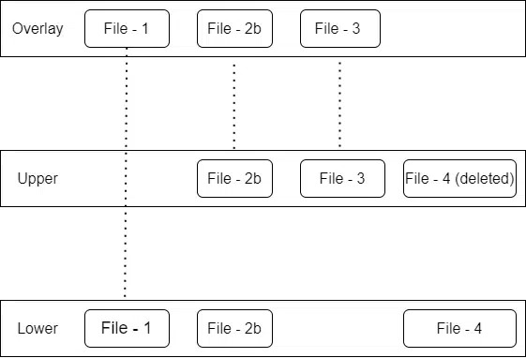
﻿
3.8 Container platforms (LXC, ﻿
Docker) :﻿
-LXC:LXC is an abbreviation used for Linux Containers which is an operating system that is used for running multiple Linux systems virtually on a controlled host via a single Linux kernel. LXC bundles with the kernel's Cgroups to provide the functionality for the process and network space instead of creating a full virtual machine and provides an isolated environment for the applications. Features provided by LXC :
- It provides Kernel namespaces such as IPC, mount, PID, network, and user.
- It provides Kernel capabilities.
- Control groups (Cgroups).
- Seccomp profile
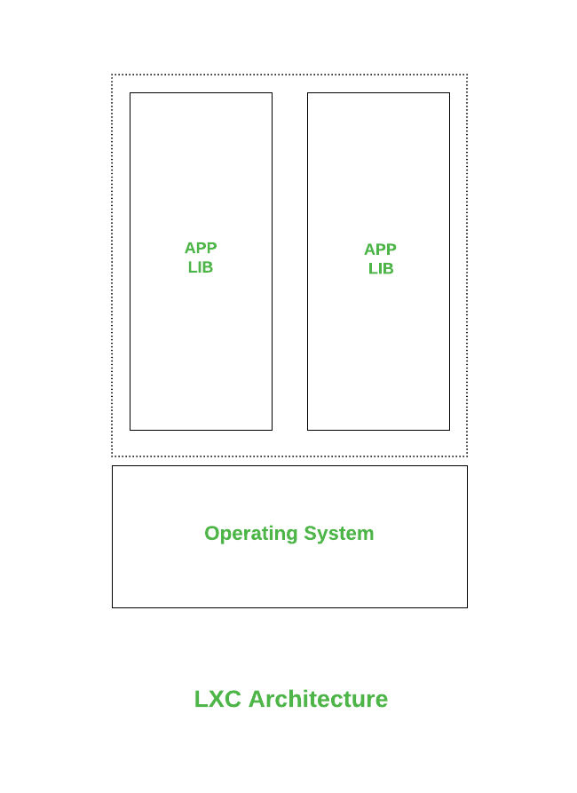
﻿
2. Docker : Docker is an open-source tool for the creation, deployment, and working of applications on a centralized platform. This makes the host's operating system to run the applications with the same Linux kernel through containers rather than creating a whole virtual machine. Using docker containers you don't need to take care of the Ram and disk space allocation. It is capable to handle the requirements on its own. Features provided by Docker :
- Docker is Fast and Easy configurable.
- Technical feasibility and increased productivity.
- Secure services through commands like secret inspect and secret create, etc.
- Provides application isolation and no container is dependent on any other.
﻿
Difference between LXC and Docker :
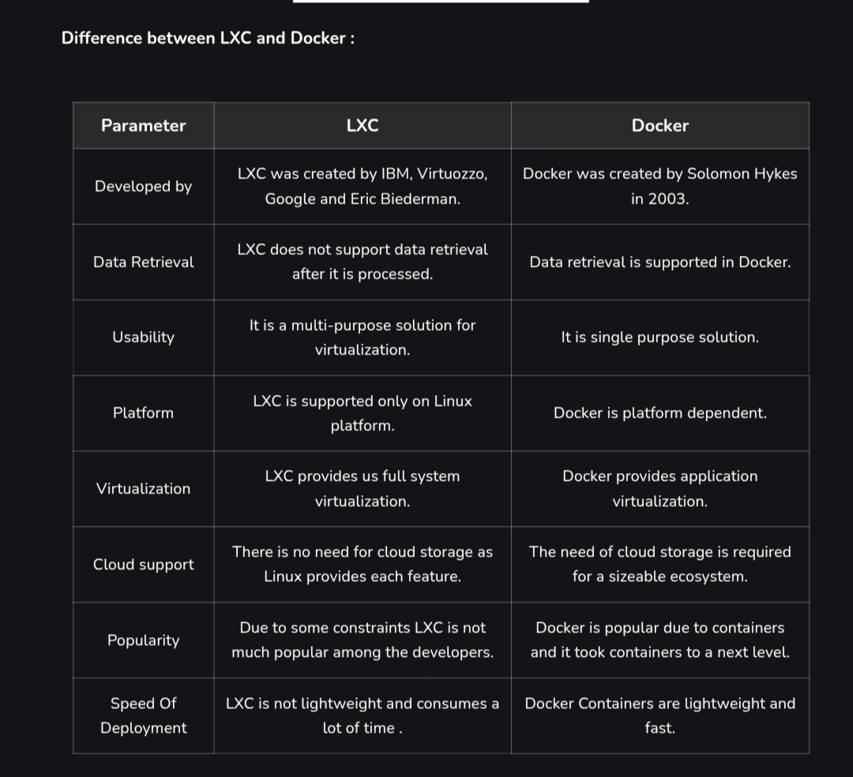
3.9 Container orchestration :﻿
Container orchestration refers to the automated management of containerized applications — including their deployment, scaling, networking, and lifecycle. It ensures that containers run smoothly across multiple environments.﻿
-Definition:﻿
Container orchestration is the automated process of deploying, managing, scaling, and networking containers. It ensures that containerized applications run efficiently across multiple servers or clusters without manual intervention.﻿
-Explanation:﻿
In modern cloud and microservices environments, applications are divided into multiple containers. Managing these containers manually is complex, especially when the number increases. Container orchestration platforms help automate this process by handling container deployment, load balancing, fault tolerance, and scaling﻿
ChatGPT

﻿
You said:
container orchestration

﻿
ChatGPT said:
Container Orchestration﻿
Container orchestration refers to the automated management of containerized applications — including their deployment, scaling, networking, and lifecycle. It ensures that containers run smoothly across multiple environments.

﻿
🚀 Definition
Container orchestration is the process of automatically deploying, managing, scaling, and networking containers.

﻿
⚙️ Key Functions
- Container Deployment – Automatically deploy containers across multiple servers or clusters.
- Scaling – Add or remove containers based on demand.
- Load Balancing – Distribute traffic among containers to ensure high performance.
- Health Monitoring – Detect and replace failed containers automatically.
- Networking and Service Discovery – Enable containers to communicate and find each other.
- Storage Management – Manage persistent storage for containers.
- Security & Configuration Management – Control access, secrets, and environment settings.

🧠 Why It’s Needed
- Manual management of containers becomes difficult at scale.
- Enables high availability, reliability, and fault tolerance.
- Simplifies application updates and rollbacks.
- Makes large-scale microservices architectures manageable.

🛠️ Popular Container Orchestration Tools
ToolDescriptionKubernetesMost widely used; open-source by Google; supports autoscaling, self-healing, and rolling updates.Docker SwarmNative to Docker; simpler setup and integration with Docker CLI.

﻿
You said:
10 marks answer

﻿
ChatGPT said:
Here’s a 10-marks answer on Container Orchestration — concise, structured, and suitable for exams or reports:

﻿
Container Orchestration (10 Marks Answer)
Definition: Container orchestration is the automated process of deploying, managing, scaling, and networking containers. It ensures that containerized applications run efficiently across multiple servers or clusters without manual intervention.﻿
Explanation: In modern cloud and microservices environments, applications are divided into multiple containers. Managing these containers manually is complex, especially when the number increases. Container orchestration platforms help automate this process by handling container deployment, load balancing, fault tolerance, and scaling.﻿
-Key Functions:
- Automated Deployment: Orchestrators automatically deploy containers on suitable hosts.
- Scaling: They scale up or down the number of containers based on traffic or load.
- Load Balancing: Incoming requests are distributed evenly among containers.
- Health Monitoring: Continuously checks container status and restarts failed ones.
- Service Discovery and Networking: Provides internal communication between containers.
- Storage Management: Attaches persistent storage volumes to containers as needed
-Popular Container Orchestration Tools
- Kubernetes: Most widely used open-source orchestration platform.
- Docker Swarm: Native orchestration tool for Docker containers.
- Apache Mesos: Handles both containerized and non-containerized workloads.
-Advantages:﻿
1 .Simplifies container management at scale.﻿
2.Ensures high availability and fault tolerance.﻿
3.Automates repetitive operational tasks.﻿
4.Improves resource utilization and efficiency.﻿
Example:﻿
In a microservices-based application, Kubernetes can automatically deploy multiple services (like frontend, backend, and database), monitor their health, restart failed containers, and balance the load among them.﻿
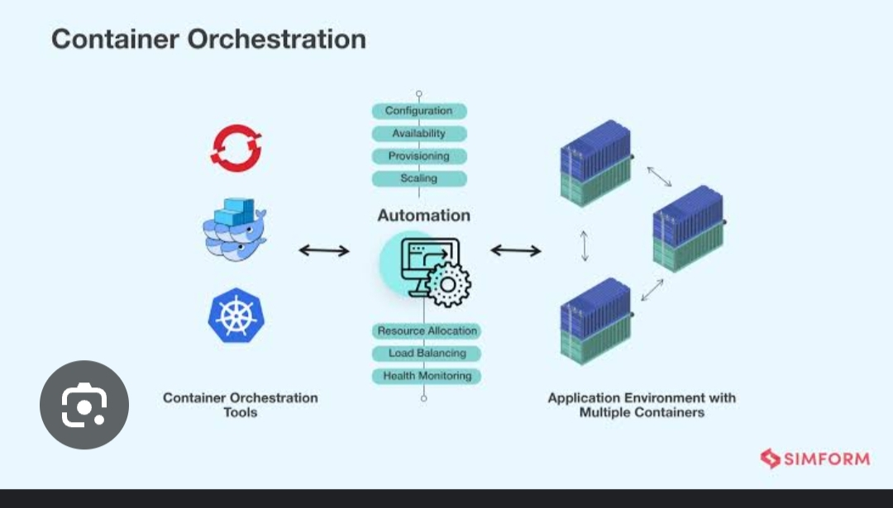
3.10﻿
Docker Swarm and Kubernetes:﻿
-Docker Swarm﻿
Docker Swarm is a group of physical/virtual machines that are meant for running Docker applications and have been configured with the perspective of joining together to form a cluster. Docker Swarm is a native clustering tool for Docker that has been part of the core since version 1.12. It lets you manage and organize a cluster of Docker nodes and allows you to interact with them like a single system. It provides optimality for your IT resources by scheduling containers to run on the aptest host and balancing workloads to make sure that containers are loaded/launched where there are enough resources. All of this is done while maintaining the performance standards that you define. ﻿
-Advantages of Docker Swarm﻿
1.Easy of Use: Docker Swarm is user-friendly native component of Docker environment. It is known for its simplicity and easy of use for service deployment and container management of simple operations that can be completed by users.﻿
2.Built-In Orchestration: It facilitates that users can easily manage and develop the containerized apps with docker orchestration features.﻿
Integration with Docker Ecosystem: It provides a consistent environment to create a smooth integration of docker swarm with other docker toolsand services. It makes the users to feel easy compatibility and adoption for integration.﻿
Disadvantages of Docker Swarm﻿
Limited feature set compared to 3.Kubernetes: Docker Swarm may not have all the advanced functionality that seen in high-level orchestrators like kubernetes Even though it provides the most fundamental orchestration functions. Kubernetes could be the better fit for organizations with complex deployment requirements.﻿
4.Smaller Community and Ecosystem: Docker Swarm has smaller community support compared to Kubernetes, which means there are fewer plugins, resources and community driver solutions. It result in assisting and troubleshooting at a slower rate on compared to kubernetes﻿
-Disadvantages of Docker Swarm﻿
Limited feature set compared to 1.Kubernetes: Docker Swarm may not have all the advanced functionality that seen in high-level orchestrators like kubernetes Even though it provides the most fundamental orchestration functions. Kubernetes could be the better fit for organizations with complex deployment requirements.﻿
2.Smaller Community and Ecosystem: Docker Swarm has smaller community support compared to Kubernetes, which means there are fewer plugins, resources and community driver solutions. It result in assisting and troubleshooting at a slower rate on compared to kubernetes.﻿
-Kubernetes﻿
Kubernetes is an open-source project developed by Google introduced in 2014. It is a portable, versatile, and extensible container orchestration system for managing and dealing with containerized workloads that facilitate both declarative configuration and automation. Kubernetes takes into account over 15 years of Google's experience running production loads at scale with the best ideas and practices from the community. ﻿
-Advantages of Kubernetes﻿
1.Scalability and Flexibility: Kubernetes facilitates the effortless scaling of containerized systems allowing them to effectively adjust to changing workloads. Its adaptability made to use in deployment situations in a wide range.﻿
2 .Automated and Declarative Configurations: Kubernetes reduces the manual error made by humans by improving the workflow through automation. Its declarative approach of configuring the resources made it easier to deploy, upgrade, and maintain consistency across the environment.﻿
Continuous Support and Continuous Improvement: Kubernetes comes up with continuous updates and improvements because of its growing and active community. Its facilitates with flexible development assuring a healthy environment and fast resolution of issues.﻿
Disadvantages of Kubernetes﻿
1 Complexity and Learning Curve: Developers and administrators are likely to go through a learning process when implementing and maintaining the Kubernetes due to its complexity. For the one who is familiar with the platform's architecture may face difficulties due to its complexity.﻿
2. .Resources Burden: Considering the kubernete's extensive functionalities it has considerable as resource overhead. The efficiency of the whole system may be impacted by the need for additional resources to run and maintain the Kubernetes control plane and its related components.﻿
3 Networking Challenges: Setting and maintenance of networking in Kubernetes will be challenging. If a problem in networking arises then it impacts the container-to-container communication, sometimes creating delays in performance.﻿
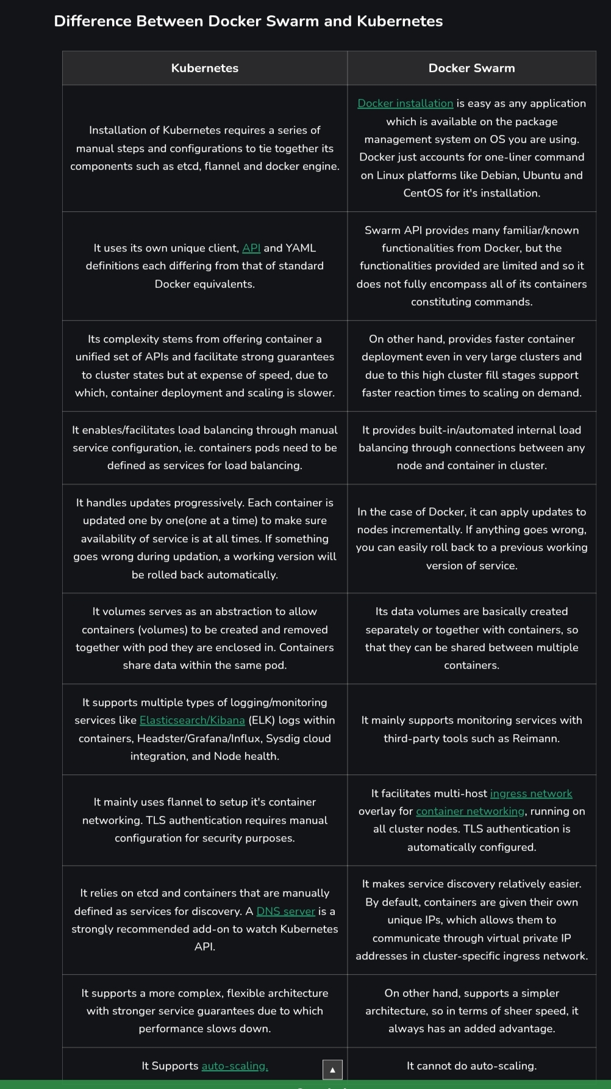
3.11public cloud VM (e.g. Amazon ﻿
EC2) and container (e.g. Amazon Elastic Container Service) offering:﻿
EC2 stands for Elastic Compute Cloud is a service from Amazon Web Services (AWS). EC2 is an on-demand computing service on the AWS cloud platform called instances. It lets you rent virtual computers to run your applications. You pay only for what you use.﻿
-The name itself explains its core value:﻿
1.Elastic: You can easily increase or decrease the number of instances or their size as your needs change.﻿
2.Compute: It provides the processing power, memory, and storage for your workloads.﻿
3 Cloud: It runs on AWS's massive, global data center infrastructure.﻿
The Core Components of an EC2 Instance﻿
Before launching an instance, you need to understand its five fundamental building blocks.﻿
1. Amazon Machine Image (AMI)﻿
An AMI is the software blueprint for your instance. It's a pre-configured template that includes the operating system (like Linux or Windows), the initial state of any patches, and any additional software. You can choose from thousands of AMIs provided by AWS, the community, or the AWS Marketplace, or you can create your own custom AMI.﻿
2. Instance Types﻿
Instance types are the hardware profiles of your virtual server. AWS offers a vast array of instance types optimized for different tasks, grouped into families:﻿
t family (e.g., t2.micro, t3.large): General Purpose, burstable instances. Perfect for web servers, development environments, and small databases.﻿
m family (e.g., m5.xlarge): General Purpose, balanced instances with a good mix of CPU, memory, and networking.﻿
c family (e.g., c5.large): Compute Optimized, with a high ratio of CPU power to memory. Ideal for CPU-intensive tasks like batch processing, media transcoding, and scientific modeling.﻿
r family (e.g., r5.large): Memory Optimized, with a high ratio of memory to CPU. Used for memory-intensive applications like large databases or in-memory caches.﻿
3. Elastic Block Store (EBS) Volumes﻿
An EBS volume is a durable, block-level storage volume that you can attach to your EC2 instance. Think of it as the virtual hard drive for your server. Because EBS volumes are persistent, your data remains intact even if you stop or terminate your EC2 instance, and you can detach a volume from one instance and attach it to another.﻿
4. Security Groups﻿
A Security Group acts as a virtual firewall for your EC2 instance, controlling all inbound and outbound traffic. You define rules that specify which protocols (e.g., SSH, HTTP), ports (e.g., 22, 80), and IP address ranges are allowed to send traffic to or receive traffic from your instance.﻿
5. Key Pairs﻿
A Key Pair, consisting of a public key and a private key, is the set of security credentials used to prove your identity when connecting to a Linux EC2 instance. AWS stores the public key, and you are responsible for securely storing the private key file (.pem). You will use this private key to SSH into your instance.﻿
------------------------------3 unit complete -----------------

